PROJECT REPORT

ON

CHATTING APP

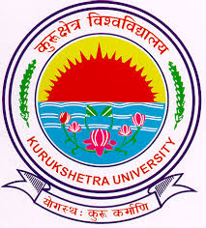

**UNIVERSITY INSTITUTE OF ENGG. AND TECHNOLOGY**

**KURUKSHETRA UNIVERSITY,**

**KURUKSHETRA**

**SUBMITTED TO:**   **SUBMITTED BY:**

MR.ATUAL SHARMA NEHA

ASSISTANT PROFESSOR CSE ‘B’

CSE DEPARTMENT 251702145